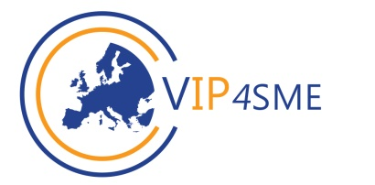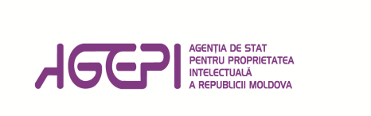

Seminar Program

„The Role of Trademarks in Promoting the Company`s Image and Sales”

Organizer:
State Agency on Intellectual Property of the Republic of Moldova (AGEPI)
with the support of project “Value Intellectual Property for SMEs - VIP4SME”
Guests:
- local economic operators;
- representatives of the business incubator, Taraclia District

Venue: Taraclia town
Date: June 6, 2017
Duration: 2,30 hours

Agenda

14.00–14.14 | Opening Session  Representative of Chamber of Commerce and Industry  Representative of AGEPI
14.14–15.00 | General aspects of protection and enforcement of trademark rights  Spaeker: Andrei Moisei, specialist coordinator, Training Division, External Relations and Promotion Department AGEPI
15.00–15.10 | Questions & Answers
15.10–16.00 | The role of trademarks in promoting the company`s image and sales. Contest „Trademark of the Year”  Speaker: Dr. Iurie Badîr, Head of Training Division, External Relations and Promotion Department AGEPI
16.00–16.30 | Business opportunities: support for Small and Medium Sized Enterprises (SMEs)  Speaker: representative of ODIMM

